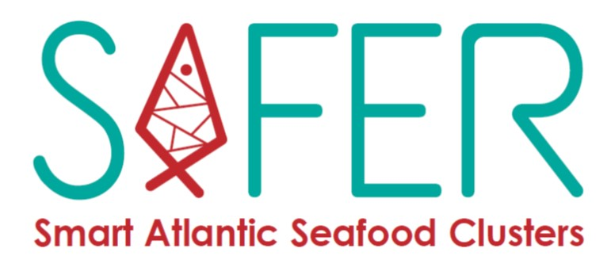

Open call for pilots extension

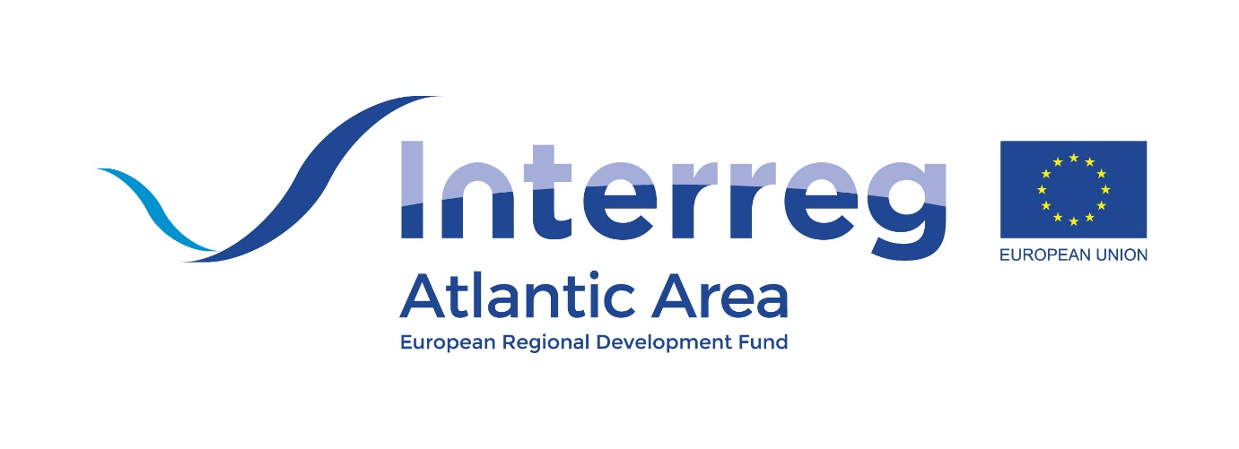
Application form

TABLE OF CONTENTS

Part A – Organisation profile 2
Part B – SAFER solution request 3
Compliance declaration 5

Part A – Organisation profile

Organisation name
Type of organisation | Select from one of the following:  - Private company (micro, small, medium size enterprise)  - National, regional, local public body (public authority, sectoral agency, public infrastructure provider)  - Other (please, specify)
Organisation address
Country
Region
Organisation website
Contact person name
Contact person position
Email address

Phone number

Please, provide a description of your organisation (core business, competences, experience) and explain your link to the seafood sector
(max. 2000 characters)

Part B – SAFER solution request
Please select which of the SAFER solution is your organisation interested:

Solution | Description
Manufacturing systems | MES (Manufacturing Execution System) IT solution, for fish, shellfish, algae, processing Industries. An integrated system of software and hardware, designed for the control of production, quality, food safety, traceability, stock, picking and distribution.
Internet of things (IoT) based solutions | IoT (Internet of Things) system that can be applied to monitor environmental or other conditions to provide real time information and assist in making decisions.  These systems use wireless technology to sense environmental conditions such as water oxygen levels, chlorophyll and temperature and send the data back to a remote database which can be accessed from anywhere by staff.  Other remote monitoring wireless solutions can be designed, especially the automatic collection of environmental data in remote areas, such as fish farms, which can be sent to the cloud to be available on employee smart phone or laptop dashboard.  Wireless based monitoring solutions can also improve efficiency on the factory floor to assist with the management of stock, and in providing automation of Quality Assurance systems.
Water treatment | Aquaculture solution consisting in an innovative process for the treatment and reuse of marine and brackish water. It is developed to enhance the productivity and to reduce the environmental impact of recirculating aquaculture systems (RAS). Based on the electrochemical oxidation technology, it only requires an electrical potential between two electrodes in water.

Please, explain the issue you want to solve by piloting this solution. Describe how the process or service you want to improve is currently carried out and what you would like to achieve from implementing the selected solution.
(max. 2000 characters)

Please, explain the resources available from your organisation to implement this solution:
Human resources | Explain the staff that would be available to work with the provider of the solution in the implementation of the pilot (requirements elicitation, assistance in the implementation, i.e. integration with existing processes systems, etc) – max 2000 characters
IT equipment and other infrastructure | Explain the current IT equipment or other infrastructure that could be put to the disposal of the pilot implementation - max 2000 characters
Pilot sustainability | Explain how your organisation will commit to sustain the solution after the SAFER project ends in June 2023 - max 2000 characters

Compliance declaration

Confidentiality and Data Protection - GDPR compliance:
The General Data Protection Regulation (2016/679/EU) guarantee that the processing of data is carried out in compliance with the fundamental rights and freedoms, as well as the dignity of the data subject with particular reference to confidentiality, personal identity and the right to data protection.
By applying, the applicant agrees on the storage and use of its personal data for the execution of the SAFER project activities. The SAFER partnership commits to handling personal data confidentially except for the call results, which will contain the following information: Information about successful SAFER solutions applications that will be made publicly available before and after the end of the project containing: awarded applicant name, type of solution provided and motivation for the requested solution (as provided by the applicant).
The processing of data that SAFER intends to carry out will be based on lawfulness and correctness in the full protection of its rights and its confidentiality pursuant to the general principles of the GDPR. Therefore, the competitors are informed of the procedure that the data provided by the applicants will be treated exclusively with reference to the procedure for which they submitted the documentation.
Applications selection and evaluation will be performed under the appropriate ethical conduct and will respect the confidentiality of the information received.

SAFER terms and conditions
I understand and agree with SAFER Terms and Conditions.

Privacy declaration
With submitting the application form you give your consent that the content of the application form will be shared with the SAFER partners. All partners will treat your information as confidential, according to the Confidentiality and Data Protection described above.
I understand and agree with the SAFER privacy declaration.
The Applicant declares that the information contained in the application form is correct and complete.

Financial Stability
I confirm that the organisation is not “in difficulty” as defined at 2.1 of the Community Guidelines and State Aid for Rescuing and Restructuring Firms in Difficulty (2004/C22/02) at the date of this declaration.

By signing this, I declare I have the required capacity to represent my organisation and agree with all the above:
Name
Position
Location
Date
Signature

