Deliverable n°

Title

Date

Logo

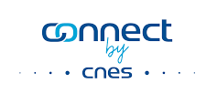
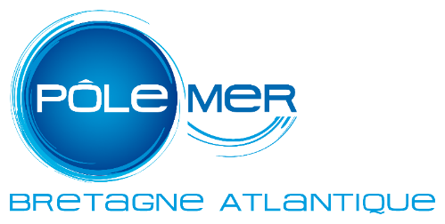

Disclaimer
MAREOS is funded by the National Center for Space Studies in the framework of the action FPA 2018-2-05 - COPERNICUS USER UPTAKE – Caroline HERSCHEL.
The content of this report represents the views of the authors only and are their sole responsibility. It cannot be considered to reflect the views of the National Center for Space Studies (CNES) or any other body. CNES do not accept any responsibility for use that may be made of the information it contains.

Table of contents

Table of figures

List of acronyms

Title

1.1 Subtitle

1.1.1 Subtitle

